**JavaScript Coding Exercise 2:**

**Leap Year:**

1. Write a program that returns True or False whether if a given year is a leap year.

A normal year has 365 days, leap years have 366, with an extra day in February. This is how you work out whether if a particular year is a leap year.

* on every year that is divisible by 4 with no remainder
* except every year that is evenly divisible by 100 with no remainder
* unless the year is also divisible by 400 with no remainder

e.g.

The year 2000:

2000 ÷ 4 = 500 (Leap)

2000 ÷ 100 = 20 (Not Leap)

2000 ÷ 400 = 5 (Leap!)

So the year 2000 is a leap year.

But the year 2100 is not a leap year because:

2100 ÷ 4 = 525 (Leap)

2100 ÷ 100 = 21 (Not Leap)

2100 ÷ 400 = 5.25 (Not Leap)

you can use the prompt() function for input or you can call you function with hard-coded value like below.

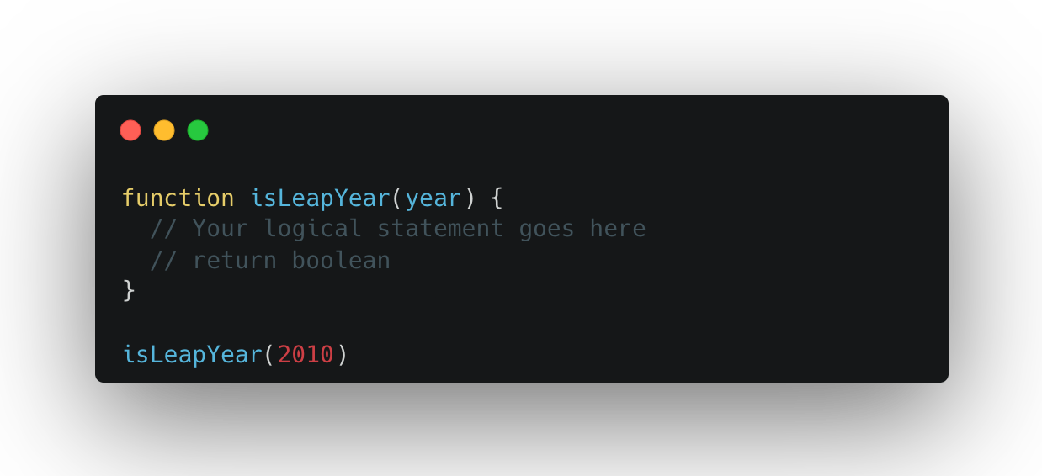

**FizzBuzz**

1. You are going to write a program that automatically prints the solution to the FizzBuzz game. These are the rules of the FizzBuzz game: Your program should print each number from 1 to 100 in turn and include number 100. But when the number is divisible by 3 then instead of printing the number, it should print "Fizz". When the number is divisible by 5, then instead of printing the number it should print "Buzz”. ` And if the number is divisible by both 3 and 5 e.g. 15 then instead of the number it should print "FizzBuzz"

Output:

**let, const and var**

1. Set the value of 'language' to the language spoken where you live (some countries have multiple languages, but just choose one)
2. Think about which variables should be const variables (which values will never change, and which might change?). Then, change these variables to const.
3. Try to change one of the changed variables now, and observe what happens

**The switch Statement**

Use a switch statement to log the following string for the given 'language':

* Chinese or mandarin: *'MOST number of native speakers!'*
* Spanish: *'2nd place in number of native speakers'*
* English: *'3rd place'*
* Nepalese: *'Number 4'*
* Arabic: *'5th most spoken language'*
* for all other simply log *'Great language too :D'*

**The Conditional (Ternary) Operator**

1. If your country's population is greater than 33million, use the ternary operator to log a string like this to the console: *'Nepal's population is above average'*. Otherwise, simply log *'Nepal's population is below average'*. Notice how only one-word changes between these two sentences!
2. After checking the result, change the population temporarily to 13 and then to 130. See the different results, and set the population back to original

**The for Loop**

1. There are elections in your country! In a small town, there are only 50voters. Use a for loop to simulate the 50 people voting, by logging a string like this to the console (for numbers 1 to 50): *'Voter number 1 is currently voting'*

**The while Loop**

1. Recreate the exercise from above for loop, but this time using a while loop
2. Reflect on what solution you like better for this task: the for loop or the while loop?

**Functions**

1. Write a function called 'describeCountry' which takes three parameters: 'country', 'population' and 'capitalCity'. Based on this input, the function returns a string with this format: *'Nepal has 6 million people and its capital city is Kathmandu'*
2. Call this function 3 times, with input data for 3 different countries. Store the returned values in 3 different variables, and log them to the console